**CENTENNIAL COLLEGE**

**COMP 397: WEB GAME PROGRAMMING**

**Project Part One: WebGL Game - GDD V1 - Level Sketch**

DUE DATE: May 19, 2025 11:59PM

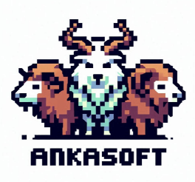

Working Title

Version #1

Student: Naomi Mendoza – 301292515

Supervisor: Prof. Alireza Moghaddam

All work Copyright © 2025 by ղąցìղì from ANKASOFT Games.

All rights reserved.

2025/05/13

TABLE OF CONTENTS

VERSION HISTORY 3

I. GAME OVERVIEW 4

II. GAME PLAY MECHANICS 5

III. CAMERA 6

IV. CONTROLS 6

Player 1: 6

Player 2: 6

V. GAME SKETCH 7

VI. MENU AND SCREEN DESCRIPTIONS 7

VII. GAME WORLD 8

VIII. LEVELS 8

Level 1: Coral Reef 8

Level 2: Dead Reef 8

Level 3: Underwater Cave 8

IX. GAME PROGRESSION 8

X. CHARACTERS 9

XI. WEAPONS 9

XII. ITEMS 9

XIII. ABILITIES 9

XIV. SCORING 10

XV. SOUND EFFECTS AND MUSIC 10

XVI. GAME ASSETS AND MULTIMEDIA 11

XVII. DESIGN NOTES 13

XVIII. FUTURE FEATURES 14

# VERSION HISTORY

Version alpha Date Created: TBD

Version beta Date Created: TBD

Version final Date Created: TBD

# I. GAME OVERVIEW

**Working Title:** MyGame

**Genre:** Casual PvP Shooter

**Target Audience:** General audiences

**Scope:** This will be an individually developed 12-week project. Assets will be simple, and gameplay will be tight to meet deadlines.

**Unique Selling Points:** xx

# II. GAME PLAY MECHANICS

The game play mechanics of SQUIDZ is designed for players to move and duel in ink-shooting match as squids. Movement, timing, and strategy is necessary to defeat the opposing player. The squid whose life reaches down to 0 loses the round. The first player to secure 3 wins, will be declared winner.

**Game Progression:**

* **Start:** Players begin each match with full life. Players start at opposite ends of the screen, with full life points, ready to target the opponent with similar ink supply.
* **Battle Phase:** Players can move freely within the designated game area. Players aim and shoot projectiles (ink blasts) at each other to reduce opponent's life. Each player aims to reduce the opponent's squid life to zero.
* **Shooting Strategies:** Each player will have 2 different buttons for shooting:  
   Small Shots – infinite usage; most effective for movement  
   Damage Shots – limited usage that depends on the ink supply; most effective for causing enemy damage
* **Strategic Maneuvers:** Players can use defensive tactics moving not just to position for shots, but also to dodge shots
* **Round End:** A round ends when one player's life reaches zero, declaring the other player as the round winner.
* **Declaring the Winner:** The first squid that wins 3 rounds, will be declared as the winner of the game. This event reaches the end of the story and ends the game.

# III. CAMERA

Top down camera view is utilized in SQUIDZ. The camera stays still to clearly display the shooting match between 2 players. The area of the camera’s position also represents the game stage where the players are allowed to move and battle.

# IV. CONTROLS

[ Keyboard Controls]

## Player 1:

Turning: Z, X

Shooting: S

## Player 2:

Turning: <, >

Shooting: L

# V. GAME SKETCH

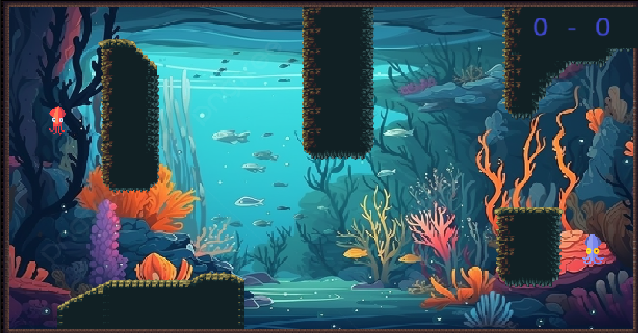

# VI. MENU AND SCREEN DESCRIPTIONS

MAIN MENU Screen:

includes buttons for **New Game**, **Options** and **Quit** (closes the Application)

NEW GAME Screen:   
  
 Prompts the Game to Start with a Countdown

Top Part of the Screen shows which Round the game is and prompted messages

Bottom Part of the Screen is divided into two sides to display the players’ stats

- Player Stats will include life points, ink supply, number of wins

**This screen would allow for the players to pause the game by pressing the **ESC** key**

In-Game PAUSE Screen (ESC button):

Freezes the progression of the game

Shows a window that includes **back to game**, **end game**, and **options** button

- End Game button prompts another message to confirm if the players are sure to end

their match. If confirmed, the players will be led back to the MAIN MENU Screen.

- Options button will show the options window without erasing the progress of the game

OPTIONS Screen (Button shows up during MAIN MENU and In-Game PAUSE Screens):

Includes **Sound Volume controls** and **Close Options** Button

# VII. GAME WORLD

Protect your deep-sea coral community!

Become the trusted guardian squid among your underwater friends. Your expert shooting skills have safeguarded the coral community from intruders for years. Yet, when challenged by another squid, the stakes are raised. Your prowess in shooting and deflecting shots finds its ultimate test.

Who will win to claim the reef?

# VIII. LEVELS

## Level 1: Coral Reef

A brightly coloured underwater reef. Large amounts of cover is provided on the left and right sides of the map, while the center is an open circular area.

## Level 2: Dead Reef

A dull grey underwater reef. Very little cover is given making it hard to avoid attacks.

## Level 3: Underwater Cave

A dark brown underwater cave system consisting of tight tunnels connecting open caverns.

# IX. GAME PROGRESSION

Each game begins with a randomly selected map. Once a players health reaches 0, the remaining player will be declared the winner, and their score will increase by one. A new round will begin with another randomly selected map. Once a player's score reaches 3, they will be declared the winner, and the game will end, returning both players to the main menu

# X. CHARACTERS

The game characters are Squid.

The focus point is cute, funny art style.

# XI. WEAPONS

Squid ink (base weapon): Fires one medium sized projectile and pushes the player back a medium distance per shot. Short reload time.

Bubble blower: Fires multiple small sized projectiles in quick succession pushing the player back a small distance each time. Small wind-up time, no reload time.

Ink cannon: Fires one large projectile and pushes the player back a large distance per shot. Long reload time, high damage projectile.

# XII. ITEMS

Players can pick up buffs which are randomly dropped during a round.

These buffs might vary from HP Regen, Ammo, DMG up, Invulnerability, Break Obstacles, ...

# XIII. ABILITIES

The abilities are associated with the available weapons. These are:

Moving ability: The player can only move by shooting. Each shot will push the player in the opposite direction of the bullet’s direction.

Turning ability: The player can turn their character model by pressing control buttons. Character can rotate a full 360 degrees in either direction (left or right). This means you can look around completely in any direction you want.

Shooting ability: When you fire your weapon, it will push you in the direction your character’s head is facing. So, if you’re looking up, firing will push you upwards; if you’re looking down, firing will push you downwards.

# XIV. SCORING

Players earn one point every time they K.O an opponent, winning the round. First to three points wins the game.

# XV. SOUND EFFECTS AND MUSIC

**Environmental Music**

Ambient sounds that match the game’s setting will enhance immersion depending on the map:

* **Level 1- Coral Reef:** A vibrant underwater sound with bubbling water and marine life will complement the brightly colored reef and provide a lively atmosphere.
* **Level 2 - Dead Reef:** Will feature dull, echoing underwater sounds with minimal marine life noises, reflecting the grey and desolate environment.
* **Level 3 - Underwater Cave:** Will have eerie, echoing sounds with dripping water and distant, mysterious noises to match the dark, tight tunnels and open caverns.

Additionally, the menu will feature different environmental sounds, and both the winning and game over screens will have distinct sounds to enhance the overall experience**.**

**Menu Navigation:** For the menu navigation, a smooth ink splash sound will provide seamless transitions between items in both the main and pause menus.

**Character Movement and Shooting:** Character movement and shooting will be accompanied by a combined shot and “woop” sound, creating a cohesive auditory experience.

**Character Damage:** When the character takes damage, a grunt sound will play, synchronized with the damage animation.

**Winning Sound:** A celebratory sound will mark the end of each round as the next level loads.

**Weapon Sounds:** Each weapon will have unique sounds to differentiate them, enhancing the gameplay experience.

**Health Increase:** A special sound will indicate when the character gains a heart and the health bar increases.

**Low Health Warning:** A danger alert sound will play when the character’s health drops below 20%, signaling a critical health level.

**Item Collection**: A collection sound will signal when an item is added to the inventory.

**Level Start:** An engaging start sound will set the tone at the beginning of each level, immersing the player right from the start.

**Power-Up Activation:** A power-up activation sound will indicate temporary boosts or abilities, adding excitement to the gameplay.

**Enemy Defeat:** A defeat sound will provide feedback when an enemy is defeated, rewarding successful combat.

# XVI. GAME ASSETS AND MULTIMEDIA

1. **Character 1:**

**Squid Player One: Inky**



**Description:**

* + **Name:** Inky
  + **Appearance:** A vibrant, blue squid with large, expressive yellow eyes and a sleek, streamlined body.
* **Animations:**
  + **Idle:** Inky sways gently in place, tentacles moving rhythmically.
  + **Movement:** Inky glides smoothly across the ground.
  + **Attack:** Inky shoots ink from its blaster with a quick, sharp motion.
  + **Special Ability:** Depending on the special power used, it either fires multiple small projectiles in quick succession, pushing Bloop back slightly each time (Bubble Blower), or fires a single large projectile, pushing Bloop back a significant distance with a powerful burst (Ink Cannon)
  + **Damage**: The character will turn red, and the animation will blink. Additionally, the eyes will turn into spirals, indicating that the character is stunned.

1. **Character 2:**

**Squid Player Two: Bloop**



* **Description:**
  + **Name:** **Bloop**
  + **Appearance:** A squid with a beautiful orange color, it seems a bit more distracted with more widely spaced eyes, its head is sharper, and it has a more robust build.
* **Animations:**
  + **Idle:** Bloop sways gently in place, tentacles moving rhythmically.
  + **Movement:** Bloop glides smoothly across the ground.
  + **Attack:** Bloop shoots ink from its blaster with a quick, sharp motion.
  + **Special Ability:** Depending on the special power used, it either fires multiple small projectiles in quick succession, pushing Bloop back slightly each time (Bubble Blower), or fires a single large projectile, pushing Bloop back a significant distance with a powerful burst (Ink Cannon)
  + **Damage**: The character will turn red, and the animation will blink. Additionally, the eyes will turn into spirals, indicating that the character is stunned.

**Items**

Well-designed items enhance gameplay by providing strategic variety and player engagement. They offer unique abilities and buffs (like HP Regen, Ammo, DMG up, Invulnerability, Break Obstacles) that can change the course of the game, making it more dynamic and enjoyable. Good design ensures items are balanced, visually appealing, and intuitive to use, contributing to a more immersive and satisfying player experience.

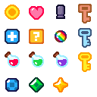 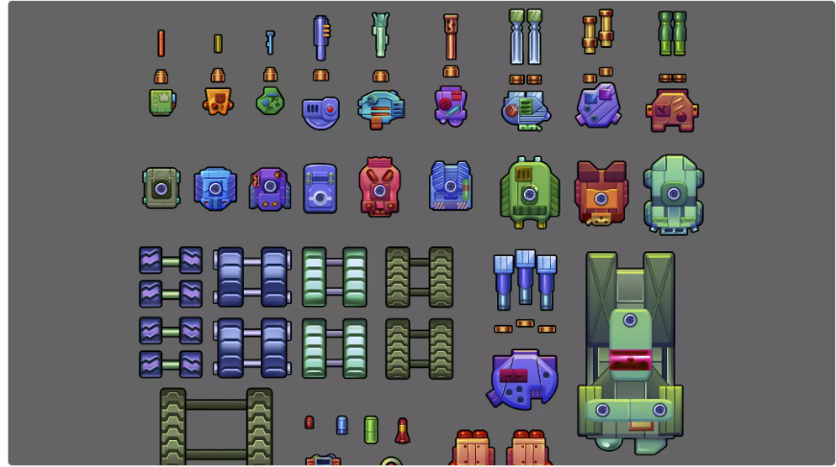

**Background selection**

A well-designed background enhances the player’s immersion, sets the tone, and influences gameplay strategy by providing visual cues and obstacles. It makes the game more engaging and enjoyable.

**Level 1: Coral Reef**

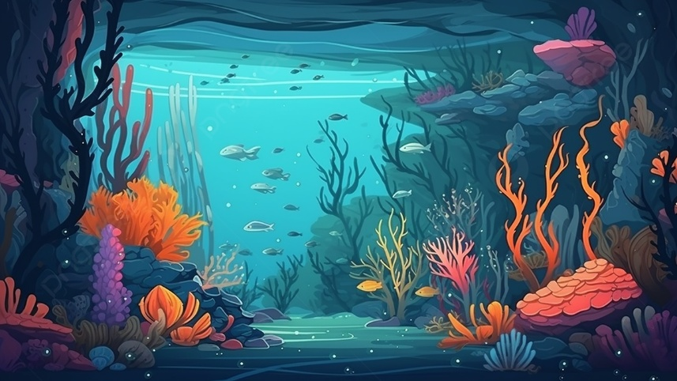

**Level 2: Dead Reef**

**Level 3: Underwater Cave**

**GUI Elements**

A well-designed GUI (Graphical User Interface) is essential for enhancing user experience and ensuring accessibility in games. High contrast between elements improves readability, allowing players to quickly grasp important information. Minimalist designs reduce clutter, making the interface visually appealing and easy to navigate. User-friendly elements, such as clear icons and straightforward menus, ensure that players can focus on the game without unnecessary distractions.

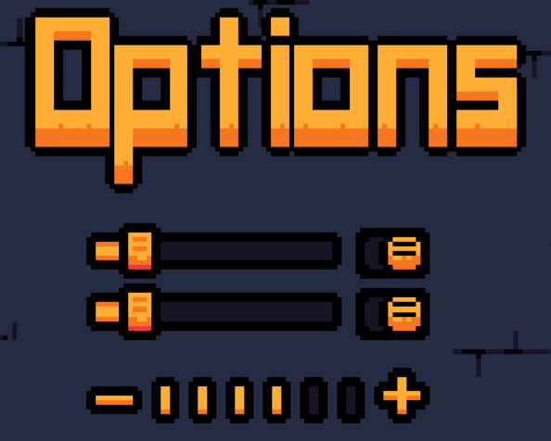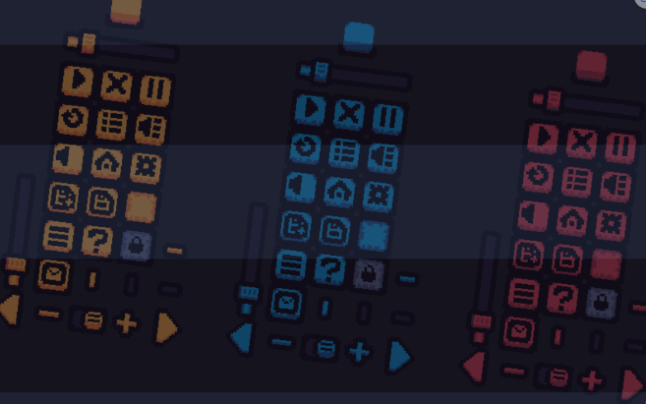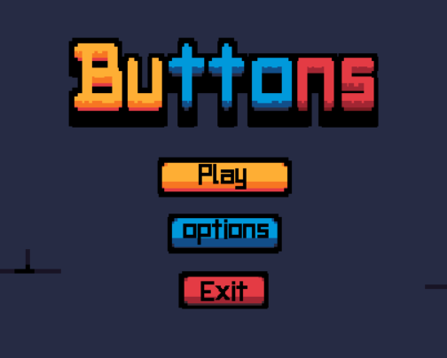

# XVII. DESIGN NOTES

Further notes will be added during development

# XVIII. FUTURE FEATURES

* Additional maps
* Continuous ink system where ink shots will disperse in the area that they land in creating a slowing effect
* Change weapons and powers based on the difficulty of the levels to keep players engaged.